| **Test Name** | | Play Game | | | |
| --- | --- | --- | --- | --- | --- |
| **Use Case Tested:** | | Multiplayer Playing | | | |
| **Test Description:** | | To test whether two players can play a game against each other | | | |
| **Pre-conditions** | | User must of logged in | | | |
| **Post-conditions** | | 2 players should be able to play the one game in a turn based setting for three rounds | | | |
| **Notes:** | |  | | | |
| **Result (Pass/Fail/Warning/Incomplete)** | |  | | | |
|  | **TEST STEP** | | **EXPECTED TEST RESULTS** | P | F |
|  | Player 1 starts a game | | That the player can start a new game | P |  |
|  | Player 1 completes round 1 | | Player 1 should be able to play a round | P |  |
|  | Game should be displayed as an open game to player 2 | | System should display the game as open and available for a player to join |  |  |
|  | Player 2 should be able to select to play the open game | | Player 2 should be able to play a round in the open game |  |  |
|  | Player 1 completes round 2 | | Player should be able to finish round 2 |  |  |
|  | Player 2 completes round 2 | | Player should be able to finish round 2 |  |  |
|  | Player 1 completes round 3 | | Player should be able to finish round 2 |  |  |
|  | Player 2 completes round 3 | | Player should be able to finish round 2 |  |  |
|  | Players finish game and winner announced | | Players should be able to complete a game of three rounds each |  |  |

|  |  |  |  |  |  |
| --- | --- | --- | --- | --- | --- |
| **Test Data Table** | | | | | |
|  | **1** | **2** | **3** | **4** | **5** |
| Roundtwotests |  |  |  |  |  |
| Round2 |  |  |  |  |  |
|  |  |  |  |  |  |

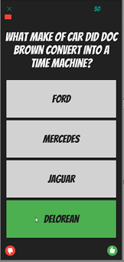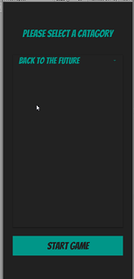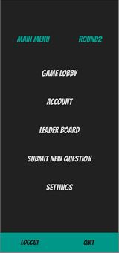

Round2 starts a game Chosen category Playing round The round ended

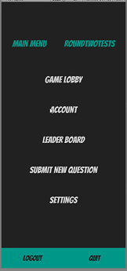Roundtwotests starts a game Open games Chosen category Playing round The round ended

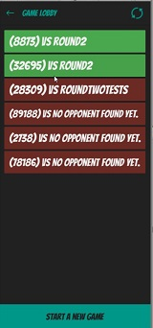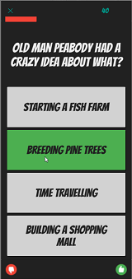

| **Test Name** | | Database Storage | | |
| --- | --- | --- | --- | --- |
| **Use Case Tested:** | | Multiplayer Playing | | |
| **Test Description:** | | To test whether database stores the open games correctly | | |
| **Pre-conditions** | | User must of logged in  There must be an open game | | |
| **Post-conditions** | | Open games should be stored in database | | |
| **Notes:** | |  | | |
| **Result (Pass/Fail/Warning/Incomplete)** | |  | | |
|  | **TEST STEP** | **EXPECTED TEST RESULTS** | P | F |
|  | Player needs to start a game and play a round | That a round is playable | P |  |
|  | At finish of the round the system connects to database and saves game as open till finished | That the open game is displayed in database until closed | P |  |

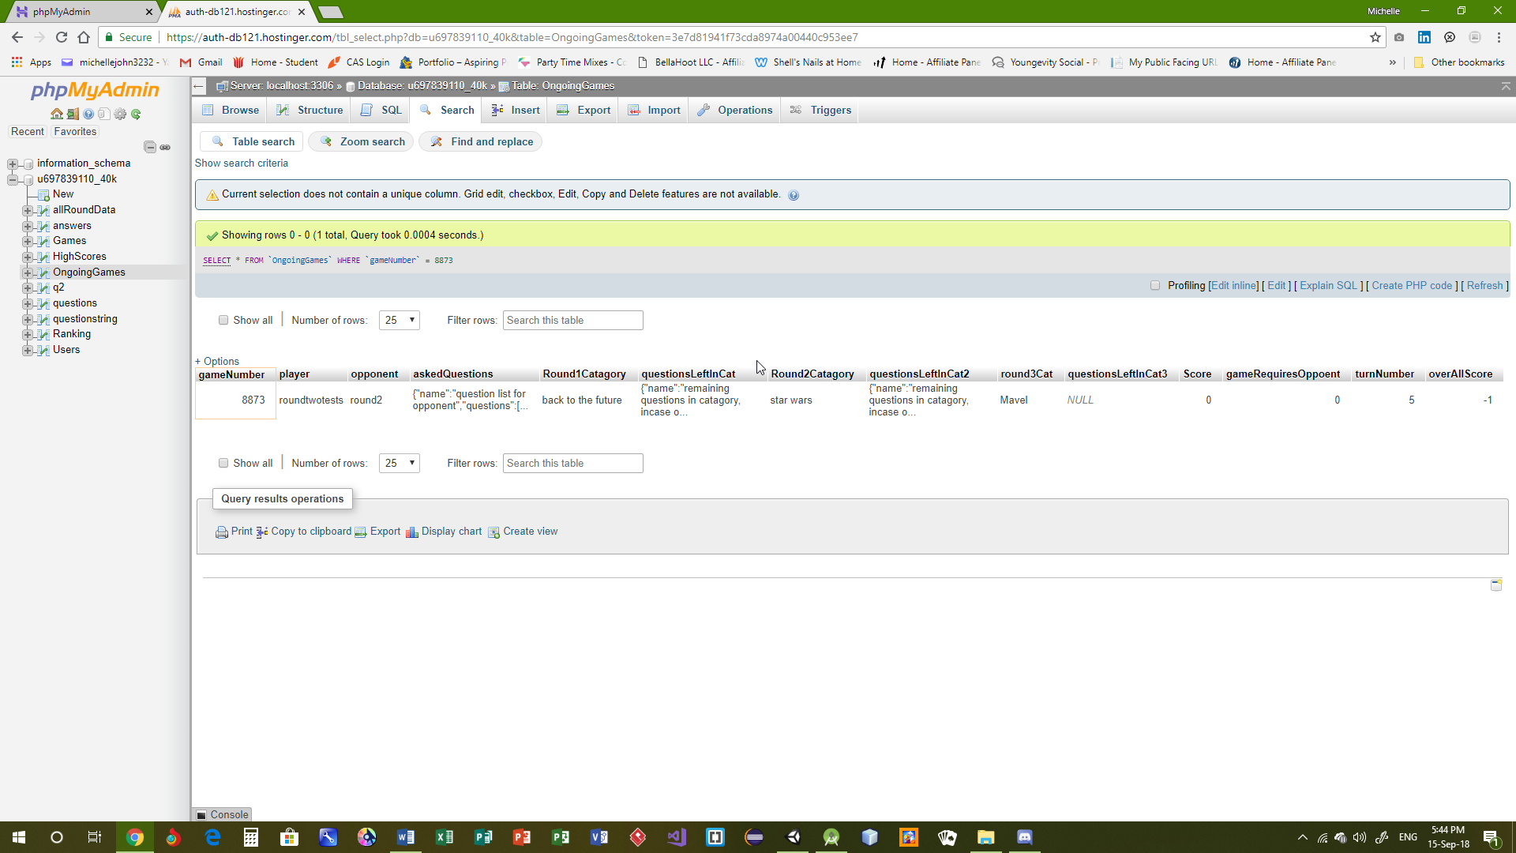

Game in database

| **Test Name** | | Turn Status | | | |
| --- | --- | --- | --- | --- | --- |
| **Use Case Tested:** | | Multiplayer Playing | | | |
| **Test Description:** | | To test whether the UI is showing the user and opponent turn status correctly | | | |
| **Pre-conditions** | | User must of logged in  Game must be open | | | |
| **Post-conditions** | | The UI should show whose turn it is at any one time in the game | | | |
| **Notes:** | |  | | | |
| **Result (Pass/Fail/Warning/Incomplete)** | |  | | | |
|  | **TEST STEP** | | **EXPECTED TEST RESULTS** | P | F |
|  | On each players turn the game should show who’s turn it is | | That the game will display which player’s turn it is |  |  |

|  |  |  |  |  |  |
| --- | --- | --- | --- | --- | --- |
| **Test Data Table** | | | | | |
|  | **1** | **2** | **3** | **4** | **5** |
| Player 1 |  |  |  |  |  |
| Player 2 |  |  |  |  |  |

| **Test Name** | | Round and Game Status | | | |
| --- | --- | --- | --- | --- | --- |
| **Use Case Tested:** | | Multiplayer Playing | | | |
| **Test Description:** | | To test whether the UI is being updated correctly to display each game and round progress? | | | |
| **Pre-conditions** | | User must of logged in | | | |
| **Post-conditions** | | That as each player progresses through each round the correct round data will be shown | | | |
| **Notes:** | |  | | | |
| **Result (Pass/Fail/Warning/Incomplete)** | |  | | | |
|  | **TEST STEP** | | **EXPECTED TEST RESULTS** | P | F |
|  | As each player plays a round the round number should increment by one till round 3 | | That as each round ends the round status will show the present round |  |  |

|  |  |  |  |  |  |
| --- | --- | --- | --- | --- | --- |
| **Test Data Table** | | | | | |
|  | **1** | **2** | **3** | **4** | **5** |
|  |  |  |  |  |  |
|  |  |  |  |  |  |

| **Test Name** | | Database Storage | | | |
| --- | --- | --- | --- | --- | --- |
| **Use Case Tested:** | | Multiplayer Playing | | | |
| **Test Description:** | | To test whether round and game progress are being stored correctly in the database | | | |
| **Pre-conditions** | | User must of logged in | | | |
| **Post-conditions** | | That after each round the database updates with the new round number | | | |
| **Notes:** | |  | | | |
| **Result (Pass/Fail/Warning/Incomplete)** | |  | | | |
|  | **TEST STEP** | | **EXPECTED TEST RESULTS** | P | F |
|  | Players play round one | | Database shows round as round one |  |  |
|  | Players play round two | | Database shows round as round two |  |  |
|  | Player 1 play round three | | Database shows round as round three |  |  |

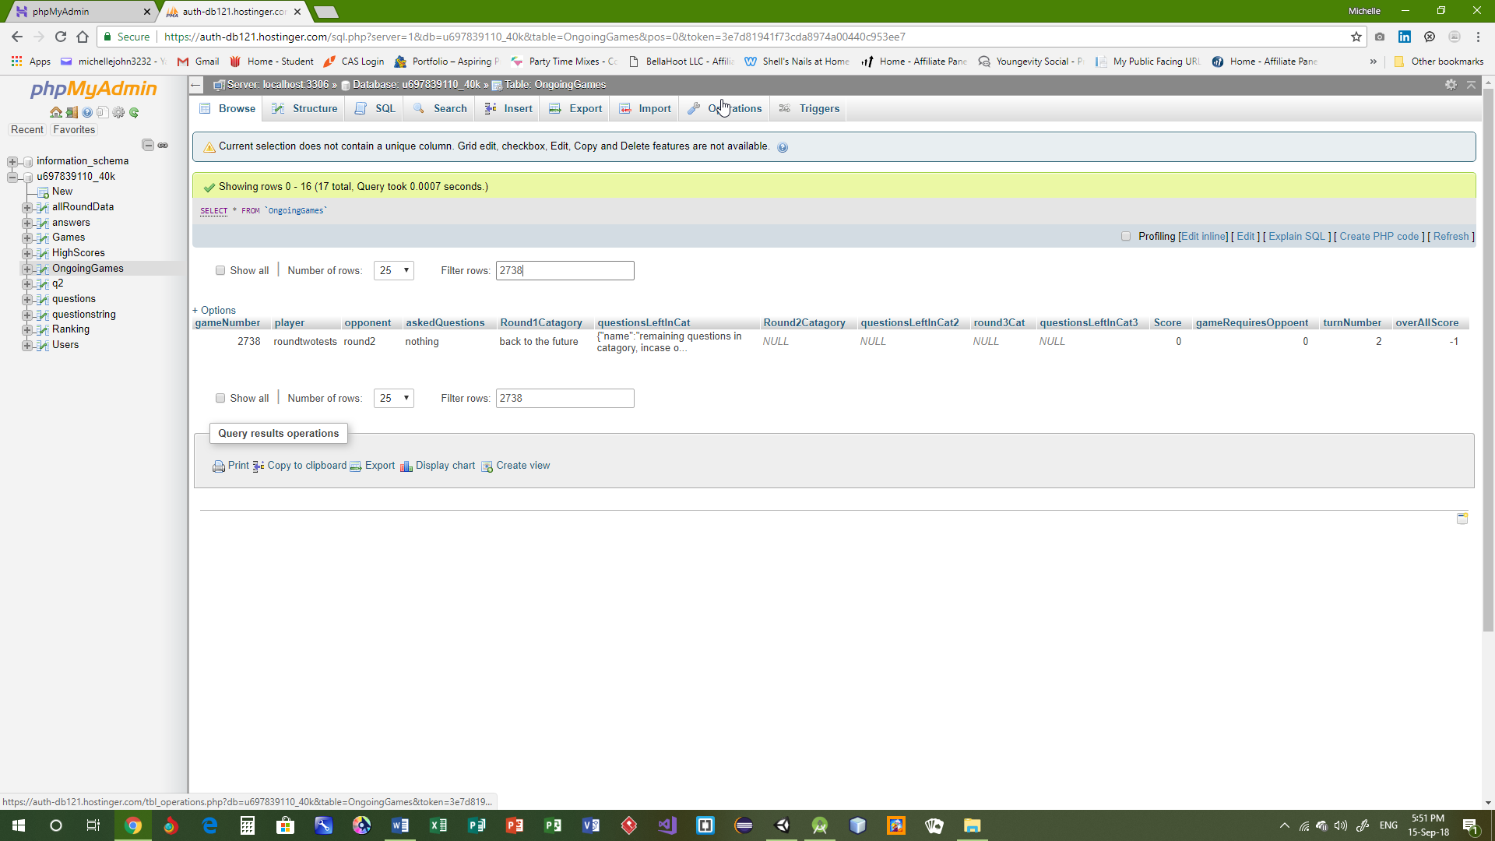

Shows a round 1 game stored

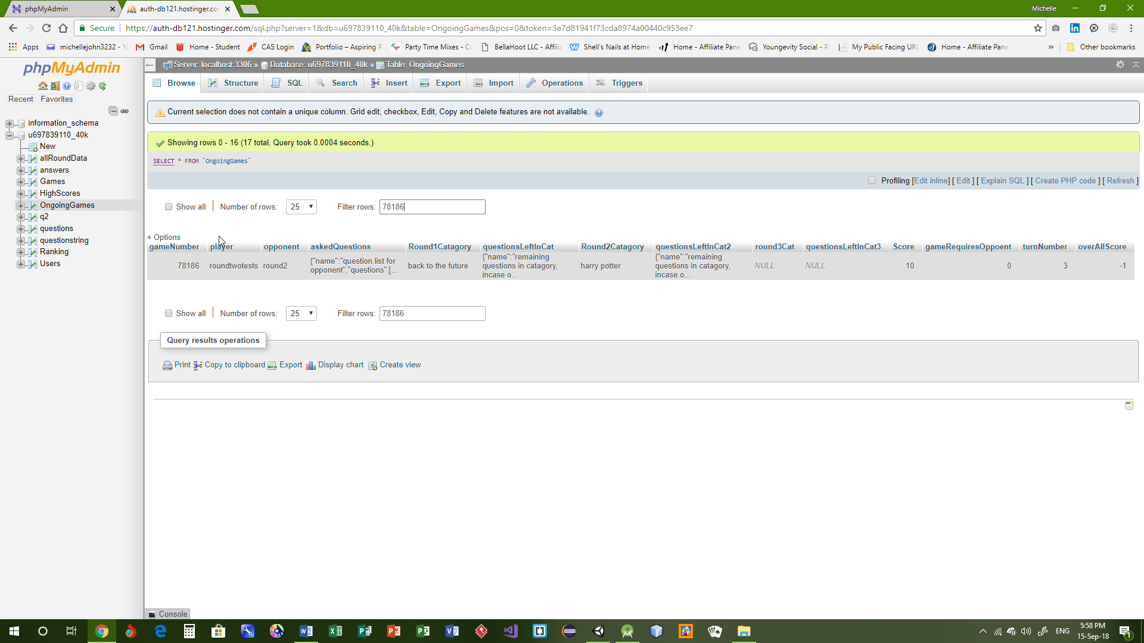

Shows a round 2 game stored

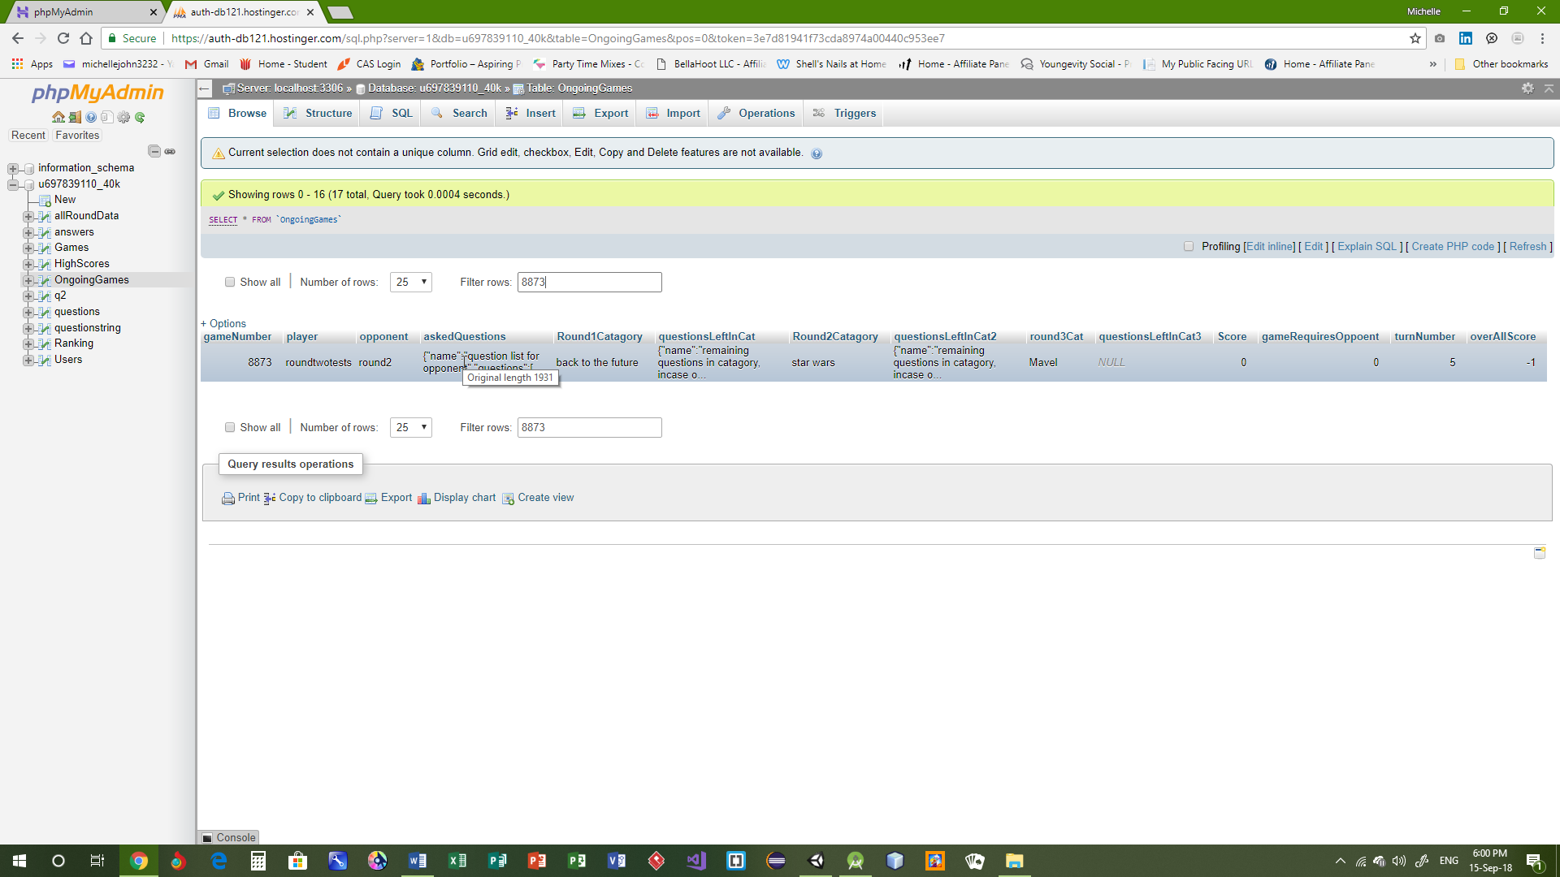

Shows a round 3 game stored

| **Test Name** | | Play and Open Multiple Games | | | |
| --- | --- | --- | --- | --- | --- |
| **Use Case Tested:** | | Multiplayer Playing | | | |
| **Test Description:** | | To test whether more than one game can be opened and played | | | |
| **Pre-conditions** | | User must of logged in  Must be at least one open game | | | |
| **Post-conditions** | | Players should be able to play from multiple open games | | | |
| **Notes:** | |  | | | |
| **Result (Pass/Fail/Warning/Incomplete)** | |  | | | |
|  | **TEST STEP** | | **EXPECTED TEST RESULTS** | P | F |
|  | Player presses start new game while an open game exists on their account | | That players can have more than one open game at any time |  |  |



Six open games two for round2

| **Name** | | Database Storage | | | |
| --- | --- | --- | --- | --- | --- |
| **Use Case Tested:** | | Multiplayer Playing | | | |
| **Test Description:** | | To test whether the database is correctly storing current games. | | | |
| **Pre-conditions** | | User must of logged in | | | |
| **Post-conditions** | | That the database can store and update the current games correctly | | | |
| **Notes:** | |  | | | |
| **Result (Pass/Fail/Warning/Incomplete)** | |  | | | |
|  | **TEST STEP** | | **EXPECTED TEST RESULTS** | P | F |
|  | Start a game | | The database should place this game in the open games table |  |  |